APPLICATION FOR ADMISSION - ( “X” for selected facility )

Care & Support Services Support only services

Clearwater House ☐ Sophia House ☐

Glencarn House ☐ Glendun House ☐

**Dumbarton House (age 45 and above)** ☐ **Belgravia Terrace** ☐ Willow House ☐

|  |  |  |  |
| --- | --- | --- | --- |
| Name |  | D.O.B. |  |
| Permanent |  | Age |  |
| Address |  |  |  |
|  |  | Tel No. |  |
| Current Address |  | Marital Status |  |
|  |  | Tel No. |  |
| NEXT OF KIN |  | G.P. |  |
| Name |  | Name |  |
| Relationship |  | Address |  |
| Address |  | Tel No. |  |
|  |  | Hospital Doctor |  |
| Tel No. |  | Tel No. |  |

Supporting care manager { if applicable }

Responsible Community Based CPN or Social worker Other referral Agency Community Team

|  |  |  |  |
| --- | --- | --- | --- |
| Name |  | Name |  |
| Position Address |  | Address |  |
| Tel No. |  | Tel No. |  |

RESPONSIBLE PSYCHIATRIST

Name

Address Tel No.

If in Hospital – who is the referrals community psychiatrist ?

# MEDICAL / PSYCHIATRIC DATA

Psychiatric Report Included ☐ ( “X” for Yes )

Current Diagnosis

Current Treatment

Hospital From To

Reason for Admission

Treatment

Diagnosis

Current Treatment (excluding medication)

Arrangements which will be made for client to see psychiatrist and/or other professionals

# CURRENT MEDICATION

Medication list

Would the applicant benefit from assistance with medication YES / NO

Has applicant ever self-harmed? YES ☐ NO ☐

Has applicant ever attempted suicide? YES ☐ NO ☐

If YES, Please specify:

|  |  |  |
| --- | --- | --- |
| Has the applicant ever attempted to harm others? | YES ☐ | NO ☐ |
| Has the applicant ever been violent towards others? | YES ☐ | NO ☐ |
| **If YES, Please specify:** |  |  |

Has the applicant had previous or current addiction issues ?

Has the client undertaken any counselling, attended voluntary groups or taken medication for addiction issues ?

# PROBATION DATA

Forensic Report included ☐

Past Convictions

|  |  |  |
| --- | --- | --- |
| Offence |  |  |
| Date  Offence |  | Sentence |
| Date |  | Sentence |

Please identify any areas of risk (including to others) if placement proceeds:

Arrangements which will be made for continued supervision if application is successful:

# COURT ORDER AND OTHER PROCESSES INCLUDING ANY RESTRICTIONS UNDER MENTAL HEALTH LEGISLATION

Current (with dates):

Expired (with dates):

# OCCUPATION AND WORK HISTORY

Social History included (this is often completed by social work or nursing keyworker) ☐ ( “X” for Yes )

|  |  |  |  |
| --- | --- | --- | --- |
| Occupation | from | TO |  |
| Occupation | from | TO |  |

Current ability to work/ Steps taken for re-employment/ Occupational Activities / Interests:

# IDENTIFIED NEEDS FOR STAY TO BE INCORPORATED INTO THE CARE - SUPPORT PLAN

Current health trust Care Plan Included ☐ ( “X” for Yes )

Daily Living Skills. Would the applicant benefit from assistance with their living area, cooking, or attending appointments ?

Individual Long term goals and preferred long term housing goal (after 2 years care - support)

Finance and Housing

Is the referral barred from the NIHE accommodation ?

Does the applicant have any special financial arrangements i.e. guardianship, Appointee ship. Or is capacity being assessed currently.

Is the applicant eligible for (or currently receive) housing Benefit

Does the applicant have substantial savings or a pension from a previous employer which may affect the applicant receiving full benefits.

Date of last ESA or Universal credit payment

Does the client have Valid Photographic identification ?

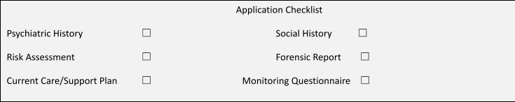Does the applicant have a current housing need ?

Dear referrer and applicant please note.

For a referral to proceed a potential service user must first visit the premises to ensure choice.

We encourage a number of visits or daily visits to facilitate Threshold’s needs assessment , risk and equality monitoring form. This also allows current service users to express any views they may have on a new person moving into their home.

When returning this document please include

1. **Completed application, signed by the applicant (service user) with a *named* supporting care manager**
2. **A psychiatric and Social History – (These may be contained in one document).**
3. **Most recent Trust care plan**
4. **Safety Plan / comprehensive risk assessment document.**
5. **Any forensic information**

Threshold staff will complete a detailed presentation based risk assessment with community keyworkers and discuss aspects of risk management with applicants with a view to developed a further support plan for the resident while in the scheme.

At Clearwater House/ Dumbarton house and Glencarn house care management support is necessary in order to assure funding criterion are met. It is also important that the applicant has access to a named community based (HSC) keyworker to support the individual in their occupancy at the house.

Thank you for your consideration.

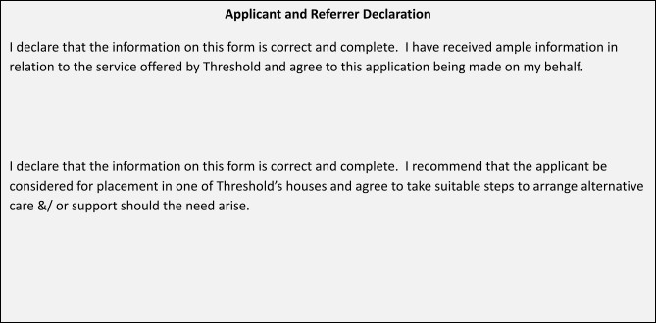

For Office Use Only

Application Received:

Confirmation of Receipt Posted: